Case Tracker

User Manual

Helping you help children at risk

* Login (pg2)
* Case List (pg3)
* Case View (pg4)
* Social Worker (pg8)
* Creating a New Case (pg9)
* Future Features (pg11)

Login

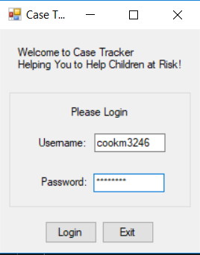

From this screen you will use the account information that the system administrator has provided you to login into the system. After you have successfully login you will be taken to the case list screen which will display all the active cases.

Case List

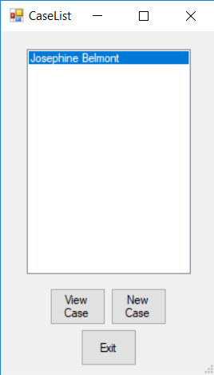

The is the first screen that you will see after logging into the system. It contains a list box that will display the current active case that are available for you to view. The cases will be sorted by the individual at risk’s name. From here you can click on one of the names in the list and view or edit the information about that individuals case by clicking the view case button near the bottom of the screen. If you wish to add a case to the list, you can click the new case button right next to the view case button which will take you to a screen that will let you enter information about for new case.

Case View

After selecting a case to view from the case list the case view screen will be displayed. This screen will have multiple tabs that are used for displaying different information.

Individual at Risk, Caregiver, Person of Interest (POI) Tabs

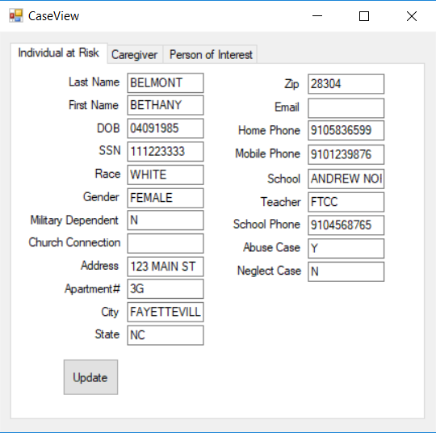

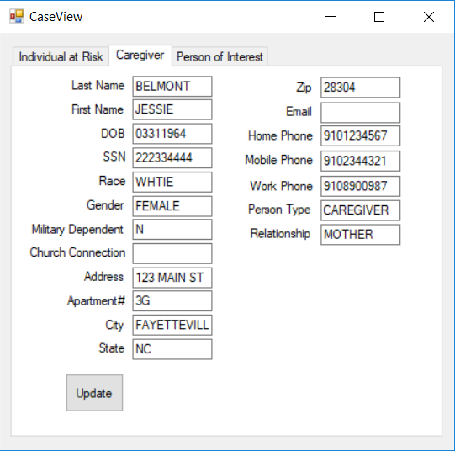

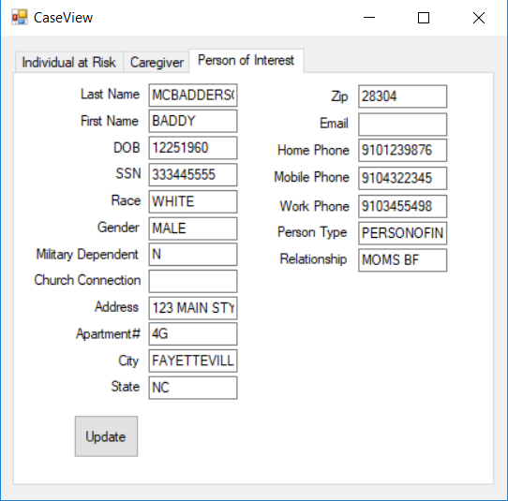

The individual at risk, caregiver and person of interest tabs will all display similar information with a few different fields between the tabs. The individual at risk will have fields for their school, school phone number, teacher and to show if the case is an abuse or neglect case. The caregiver and person of interest tabs both have a field to show what their relationship is to the individual at risk (Mother, Father, Aunt, Uncle). You can edit the information for a case by simply changing the information in a field and clicking the update button in the button left of the tab.

Social Worker Tab

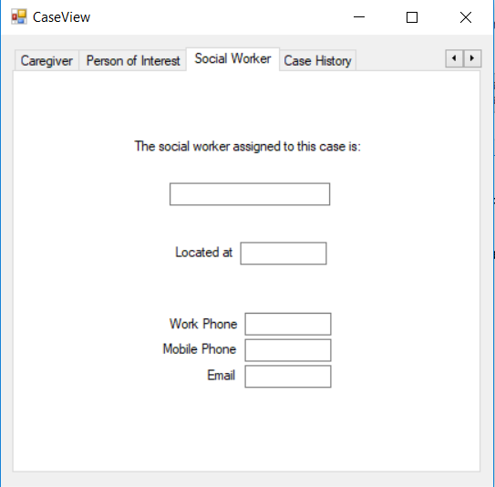

This tab will display the information for the social worker that is assigned to the case. It will show their name, where there are located, and their work, phone and email.

Creating a New Case

Once you have clicked new case you will be taken to the person form.

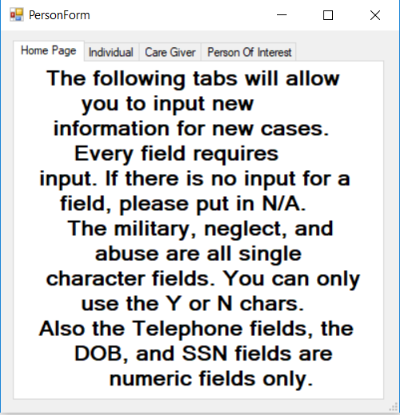

From here you will enter the information for each of the tabs. Make sure that the tabs are filled out one at a time and in order. After you have entered all the information for a tab make sure you click the save button at the bottom of the window before moving on to the next tab. Each of the tabs must be filled out completely as shown in the next picture.

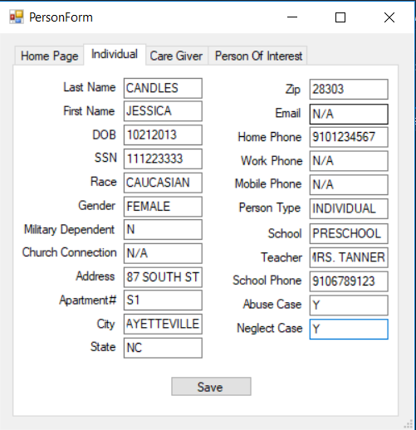

The military dependent, abuse case, and neglect case fields with only take a single character. For these fields you will ether enter a Y for yes or a N for no. any fields that you do not have information for enter N/A into the field. After you have entered and saved all the information for a new case you will need to log out and log back in before the case list will be updated with the case you just created.

Future Features

Here is a list of planed features that will be added into the program at a later date.

Time out

* When the program has been inactive for a set amount of time the program will return to the login screen and log the current user out.

Case History

* Gives the user the ability to view changes made to a case and also the ability to add notes pertaining to the case or view notes from other users about the case.

User Types

* There will be different user types based on the department that the user works for. These will be police department, department of social services and the school system.

Alert Messages

* When ever a note is added by a user the DSS worker assigned to the case will receive an email alert notifying them of the note.